http://www.dailytelegraph.com.au/newslocal/central-coast/narara-ecovillage-leads-the-country-in-environmental-technology/news-story/5c787ab938c3d937719df60cdd814e17

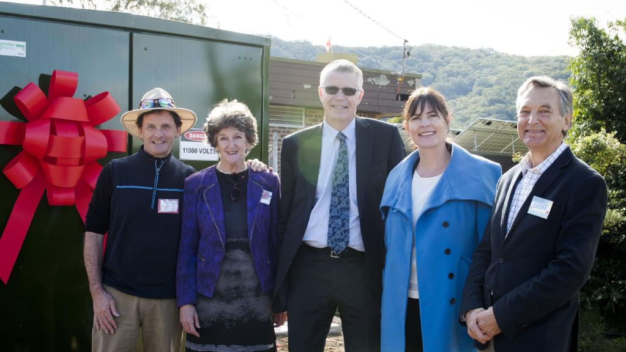Priscilla the transformer, John Talbott, NEV Project Director; Lyndall Parris, NEV Founder; Dominic Zaal, ARENA Program Manager; Lucy Wicks Federal Member for Robertson; Geoff Cameron, Project Team, NEV at Narara Eco Village. Picture: Lisa Haymes

Central Coast

Narara Ecovillage leads the country in environmental technology
Peter Way, Central Coast Gosford Express Advocate
June 9, 2017 1:57pm
Priscilla Queen of Narara is firmly ensconced at Narara Ecovillage and set to power the 150 homes soon to be built there.
One of the nation’s most advanced and environmentally friendly smart grid transformers will channel solar power and direct surplus power back to the grid.
The development received close to $1.2 million from the Federal Government, through the Australian Renewable Energy Agency (ARENA), to help fund the innovative Narara Ecovillage Smart Grid.
ARENA’s support for the project, led by NEV Power, helped power the installation of the smart grid, which is computerised and self-contained.
It will manage the consumption and storage of energy for the 150 homes and several communal and commercial facilities on the former site of the Gosford Horticultural Institute research station.
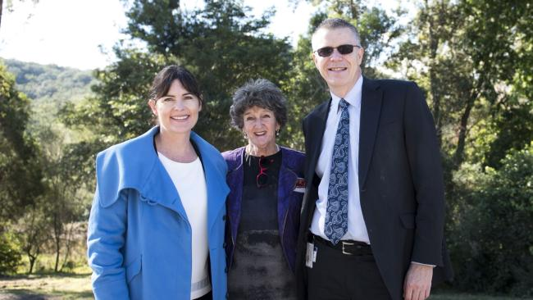
Lucy Wicks Federal Member for Robertson; Lyndall Parris, NEV Founder; Dominic Zaal, ARENA Program Manager at Narara Eco Village. Picture: Lisa Haymes
Robertson federal Liberal MP Lucy Wicks announced the funding at the Narara Ecovillage on Tuesday.
“The Narara Ecovillage is an outstanding initiative that is leading the way in its field, not just on the Central Coast but around the world,” Mrs Wicks said.
“The smart grid is set to be one of Australia’s most advanced community-owned energy grids.
“This grant will (help the village) become a carbon-neutral sustainable living centre.”
Narara Ecovillage founder Lyndall Parris, 68, said it was community-mindedness and social connectivity, not the environment, that sparked the idea for the community buy-in estate model. “When I turned 50, two of my best friends’ husbands died, leaving them each to bring up two children,” she said.
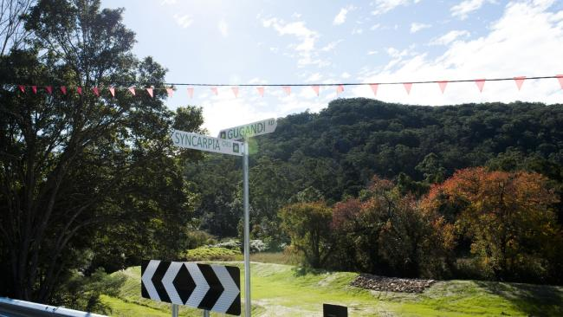Narara Eco Village with new street signs. Picture: Lisa Haymes
“I thought ‘this is hard’ and I often thought if we were living together in a community then my husband Dave could go to a football game with their children, or he could go to the basketball with them.
“I lived in one part of Sydney, one of my friends lived in another part, and the other friend lived in the country.
“That was the seed for me, it wasn’t the environmental side of it, it was the social side.”
The former accountant originally thought her dream community would take shape on the South Coast. “Then this property came on the market and we came here and thought this is God’s own country, this is where the ecovillage has to be,” she said.
The ecovillage will also have its own dam and water treatment plant ready for action when the first stage of homes start being built later this year.

